**E-Marketing**

**Definition: E-Marketing**

E-Marketing (Electronic Marketing) are also known as Internet Marketing, Web Marketing, Digital Marketing, or Online Marketing. E-marketing is the process of marketing a product or service using the Internet. Emarkerting not only includes marketing on the Internet, but also includes marketing done via e-mail and wireless media. It uses a range of technologies to help connect businesses to their customers.

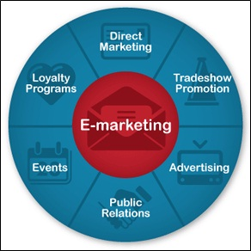

**Advantages of E-marketing**

Certain advantages of emarketing are discussed as below:

1. Much better return on investmentfrom than that of traditional marketing

2. E-marketing means reduced marketing campaign cost as the marketing is done through the internet

3. Fast result of the campaign

4. Easy monitoring through the web tracking capabilities help make emarketing highly efficienct

5. Using e-marketing, viral content can be made, which helps in **[viral marketing](https://www.mbaskool.com/business-concepts/marketing-and-strategy-terms/2189-viral-marketing.html)**.

**Types of e-marketing**

There are several ways in which companies can use internet for marketing. Some ways of e-marketing are:

1. Article marketing

2. Affiliate marketing

3. Video marketing

4. Email marketing

5. Blogging

All these and other methods help a company or brand in e-marketing and reaching customer through the internet.

Hence, this concludes the definition of E-Marketing along with its overview.

## ****E-Marketing Meaning****

E-marketing is referred to those strategies and techniques which utilized online ways to reach target customers. There are millions of Internet users that daily access different websites using a variety of tools like computers, laptops, tablet and smart or android phone devices, and the number of internet users are increasing very rapidly. So every business seems to be jumping on the internet marketing bandwagon. The internet is most powerful tool that can put any business on solid footing with market leaders companies. There are many free as well as economical way on internet to promote your business. Successful companies must ask themselves some tough questions about how they will promote their business online? What their company expectations are? And what will be their plan to meet those expectations? After answer all these questions a company should design an effective marketing plan.

## Definition

E marketing also known as online or internet advertising which uses the internet technology to promote online message to customer. E-marketing examples are email or social media advertising, web banners and mobile advertising.

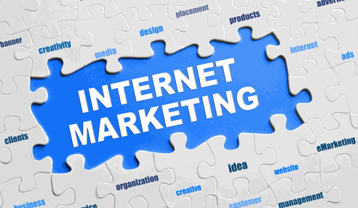

## ****Advantages and Disadvantages of E-Marketing****

### ****Advantage of E-Marketing****

1. Internet provides 24 hours and 7 days “24/7” service to its users. So you can build and make customers relationships worldwide, and your customer can shop or order product at any time.
2. The cost of spreading your message on internet is nothing. Many social media sites like Facebook, Linkedin and Google plus allow you freely advertise and promote your business.
3. You can easy and instantly update your registered customers or subscribers through email.
4. Visitors or potential customers of your website can get up to the minute information on each visit.
5. If you are having a sale, your customers can start shopping at the discounted prices literally as soon as they open their email.
6. If a company has an information sensitive business, like a law firm, newspaper or online magazine, that company can also deliver its products directly to customers without having to use a courier.

[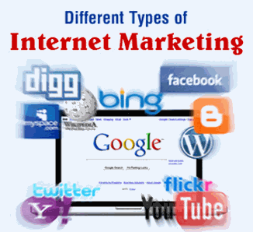](http://www.studylecturenotes.com/sites/default/files/field/image/advantages%20and%20disadvantages%20of%20internet%20marketing.png)

### ****Disadvantages of E-Marketing****

1. If you want a strong online advertising campaign you have to spend money. The cost of web site design, software, hardware, maintenance of your business site, online distribution costs and invested time, all must be factored into the cost of providing your service or product online.
2. Almost over 60% of households now a day shop online. While that numbers are continuously growing, your company needs to reach maximum people.
3. Some people prefer the live interaction when they buy any product. And if your company has a small business with one location, this may also deter customers from buying who lives on long distances.
4. Your company should have updated information on your site. This requires research and skills and thus timing of updates is also critical.
5. Is your company web site secure? There are many incorrect stereotypes about the security of the internet. As a result, many visitors of your business web site will not want to use their credit card to make a purchase. So there is a fear in the minds of your visitors of having their credit card info stolen.

Pulling it all together we can say that there are many pros and cons. So it’s important for your company to consider each when designing your **e-marketing strategy**. You can easily overcome disadvantages, but this can happen only when you will view the customer experience from the eyes of your customer, not from the eyes of an internet marketer.